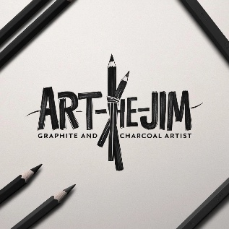**Art The Jim**

**Charcoal & Graphite Art Pricing Catalogue (2025)**

# Standard Artwork (Unframed)

Size Level of Detail Black & White (KES) With Color Accents (KES)

A2 Exhibition Quality 4000 5000

A3 Hyper Realistic 2700 3200

A4 Detailed Portrait 2000 2500

A5 Simple Portrait 1000 2000

# Add-On Options

Framing (Basic) 1000 – 2000

Framing (Premium) 2500 – 4500

Background Design +1000 – 2000

Fast-Track (3 Days) +20% of total

# Commission Guidelines

* Booking Fee: 50% upfront to confirm the order.
* Delivery Time: 5–10 days depending on size and detail.
* Delivery Options: Pickup/shipping (courier fees apply).
* Revisions: 1 minor revision included; major changes after completion attract a fee.

# Payment Methods

* M-Pesa Number-0746514841
* Cash (for local pickups)